Unit 2: Exploring and Challenging Gender Stereotypes in Primary Schools
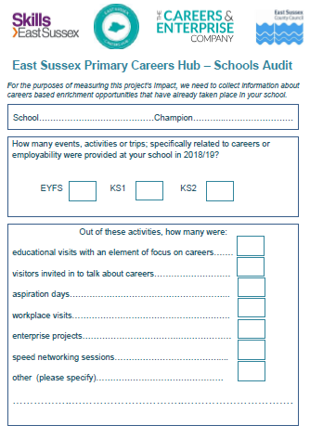
When should I use this pack and how much time do I need?
Once Careers Related Learning has been introduced, the next step is to explore how ingrained gender stereotypes are in your school and find ways to challenge them. Your staff will have completed the Capacity Audit in Unit 1, where your staff scored their ability to challenge gender stereotypes out of 5; this data can act as your baseline.
You will need no more than an hour to familiarise yourself with the materials in this pack, and you will need to allocate some staff meeting time to introduce the theme and plan collaboratively. The unit could take place intensively as part of a careers week or spread out into weekly sessions if this works better within the curriculum.
Challenging Gender Stereotypes will be an underlying theme throughout the project as it is a key issue in Careers. In the report ‘What Works? Career-related learning for primary schools’ it is stated;
‘Children form stereotypical views of the world from an early age. Biased assumptions lead to a narrowing of career aspirations and an inability to relate learning to a world beyond school.’
(The Careers and Enterprise Company 2018)
By working through this unit your school community will have time to reflect on what systems contribute to building stereotypes in your school, and by challenging them you will broaden the horizons for your current and future cohorts.

Contents
Resource | Format | Audience | Reference
Plan | PDF | Staff | A1
All Pupil Survey - Baseline | PDF | EYFS/ KS1 / KS2 SEND | A2
Staff Meeting Presentation | PowerPoint | Staff | A3
Assembly | PowerPoint | All | A4
Aspiration and Gender Task A | PDF | EYFS/ KS1 / SEND | A5A
Aspiration and Gender Task B | PDF | KS2 | A5B
Gender Audit 1 | PDF | EYFS | A6
Gender Audit 2 | PDF | EYFS | A7
Staff Feedback Form | PDF | All | A8
Design a Gender-Neutral T Shirt | PDF | All | A9
Draw an Employee | Word | All | A10
All Pupil Survey Impact Measurement | PDF | All | A11

All pupil survey - baseline
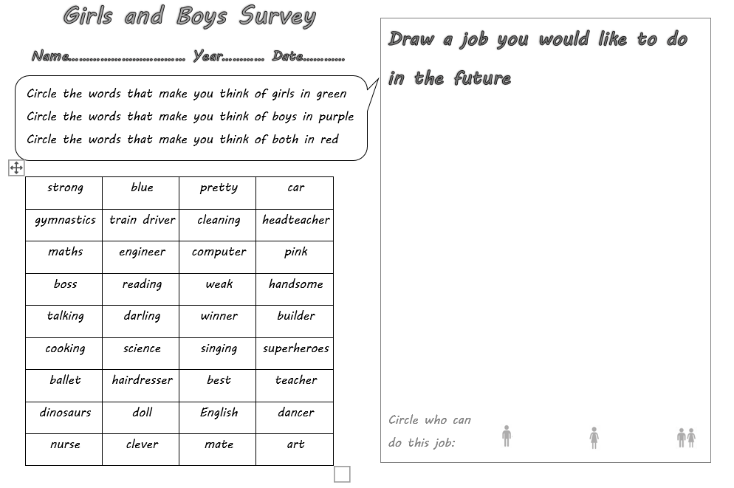
This survey should be completed by the whole school before you start. The completed surveys can be used for data handling in KS2 so that graphs can be produced to share the results. This should give an insight into gender stereotypes amongst the children by showing the language they associate with either or both sexes, and the proportion of children from each sex who aspire to certain jobs. Once you have the results, take time to discuss them in the staff team, consider how will it affect your curriculum, topics and school systems? You may want to share the results with parents along with the presentation later in the unit.
Note: this survey should be repeated following the unit to measure impact.
Nouns | Adjectives | Activities | Jobs | Subjects
car | strong | gymnastics | train driver | maths
computer | blue | cleaning | headteacher | science
boss | pretty | reading | engineer | English
weak | pink | talking | hairdresser | art
darling | best | cooking | teacher
winner | clever | singing | dancer
superheroes | handsome | ballet | nurse
dinosaurs |  |  | builder
doll
mate

Staff meeting
Included in this resource is a presentation that can be used for staff and parents to introduce the issues. Once the presentation has been given, time should be given to discuss ways forward, look at the resources and plan the learning journey. Some effort will need to be made to invite visitors in to school to discuss their careers - staff may want to plan a Primary Futures ‘What’s my line’ event, careers day or a series of assemblies (as a result of Covid 19 these sessions are now available virtually). Please see the ‘further reading’ section for more guidance and inspiration. Visitors invited in should challenge gender stereotypes as much as possible; for example, a male nurse or dancer, a female engineer, building operative or scientist. There may be opportunities for staff CPD. Consideration should be given to how school policies may need to be adapted as changes take place.
Both schools and employers should refer to the essential skills highlighted in the Skills Builder Framework (www.skillsbuilder.org), namely listening, presenting, problem solving, creativity, aiming high, staying positive, leadership and teamwork.

The learning journey
Please see the planning document (A1) for an outline of the resources to accompany this unit. Activities are sorted into key stages for differentiation and teachers may find it useful to use activities from different key stage groups in order to support children with SEND/EAL.

The Skills Films

The Skills Films will add greater depth to this learning, introducing children to a range of industry champions discussing their roles. They can be accessed on YouTube at the following link here. Support materials to use with the films can be accessed here.

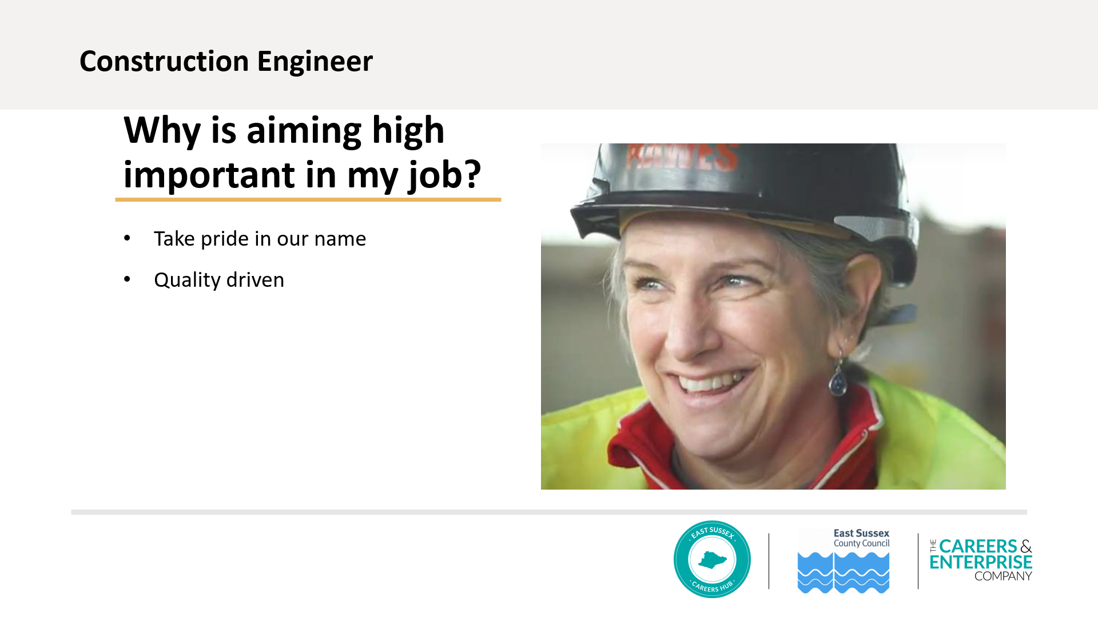

Further Reading

Careers and Enterprise Company – What Works? Career-related learning in primary schools | Linking schools and colleges to employers and to help them deliver world-class careers support, preparing and inspiring young people for the fast-changing world of work | https://www.careersandenterprise.co.uk/sites/default/files/uploaded/1145_what_works_primary_v7_digital.pdf | This document sets out all the issues around careers in primary school and provides case studies to guide and inspire.
Education and Employers | Inspiring the future: Careers Related Learning research and support materials. | https://www.inspiringthefuture.org/ | Find guidance on ‘What’s My Line’ event, and links to ‘Redrawing the Future’; the largest survey into aspiration of primary children.
iCould  Careers Site | This website has lots of videos to explain a wide range of careers, useful if you have a specific career to search for. | https://icould.com/ | Videos explaining skills needed for careers
My World of Work  Careers Site | This is a Scottish website, with free resources. Free to register which also gives access to interactive ‘tools’;  Registering gives access to ‘strengths tool’ and ‘skills tool’ for self-assessment. | https://www.myworldofwork.co.uk/ | Resourced lesson plans with PowerPoints, on subjects such as challenging gender stereotypes, and knowing your strengths
BBC Bitesize Careers | This is a great resource, easy to find lots of careers explained through high quality videos. | https://www.bbc.co.uk/bitesize/careers | Find a career by subject, such as ‘Careers that use science’
Employees Matter | Take your child to work day | https://employeesmatter.co.uk/bring-your-child-to-work-day/ | Think a ‘take your child to work day’ might work at your school? Look here for some practical guidance and case studies.
Prospects – University of Kent | Get an insight into different job sectors | https://www.prospects.ac.uk/ | Job sectors https://www.prospects.ac.uk/jobs-and-work-experience/job-sectors

